Pod restart policy will be defined under Pod level not Container level

There are 3 types of Pod Lifecycle Restart Policies

1. Never (--restart Never)

Containers will not be started by kubelet due to any exit code (>=0).

UseCase: Application that fails and where kubelet will not try to start.

1. Always-Default (--restart Always)

Kubelet will try to restart containers exited with (>=0) means failed or stopped due to any reason.

Note: If we don’t pass any restart policy **Always** will be applied

UseCase: Application that needs to be started due to any failure to avoid downtime.

1. OnFailure (--restart OnFailure)

Containers will be started by kubelet only if it was failed with exit code (>0)

UseCase: Situation where we need to run application & find the root cause of failure if stopped due to exit code >0

apiVersion: v1

kind: Pod

metadata:

  name: nginx-policy

  labels:

   app: nginx

   type: webserver

spec:

  containers:

    - name: container-write

      image: alpine

      command: ["/bin/sh"]

      args: ["-c", "while true;do date >> /var/tmp/index.html;sleep 10;done"]

      volumeMounts:

        - name: share-volume

          mountPath: /var/tmp

    - name: container-serve

      image: nginx

      ports:

        - containerPort: 80

          name: http

          hostPort: 8090

          protocol: TCP

      volumeMounts:

        - name: share-volume

          mountPath: /usr/share/nginx/html

  volumes:

    - name: share-volume

      emptyDir: {}



After running the code I got an error which is shown in the above picture. The error is at 26 th line. Actually volumes section will be written straightly to the containers (spec.volumes). after rectifying the code run the below command.

# kubectl create –f Deployment/nginx-policy.yaml

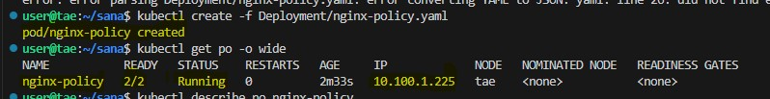

Actually after creation of the pod when the first time we run the below command, we can’t identifty the restart policy of the pod. But I have closed the machine and started again That’s why in the output of the below command it is showing the *Restart count1*

# kubectl describe po nginx-policy

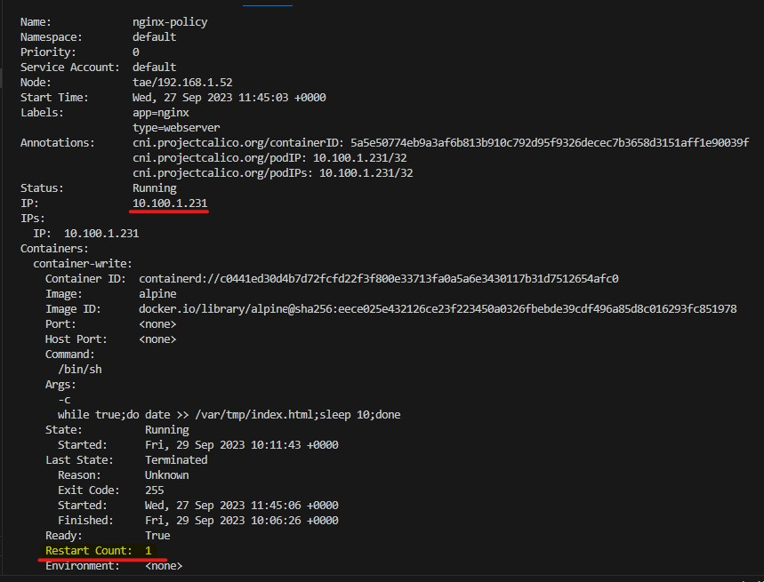

To print the output of the pod in yaml format run the below command

# kubectl get po nginx-policy –o yaml

After executing the above command we will get output like below In that notice that the restartPolicy: Always

As we know the default policy a pod’s restart Policy is Always.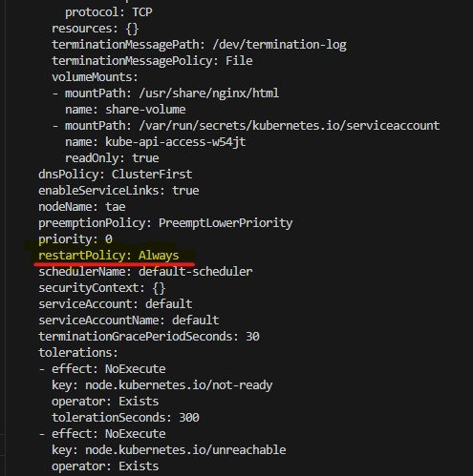

The usage of this particular policy Always is whenever the container inside the pod gets exited with due to any of the reason (>=0) the kubelet will try to restart the container.

* For example let’s create a scenario to check that kubelet will try to start the container. For that I just did a small change in the above yaml code.

I just added “exit 0” which means the container gets exited successfully.

* args: ["-c", "while true;do date >> /var/tmp/index.html;sleep 10;exit 0;done"]

create the pod using the below command.

# kubectl create –f Deployment/nginx-policy.yaml

After creation of the container run the below command. This command is used to watch our pod .

# kubectl get po –o wide nginx-policy –w

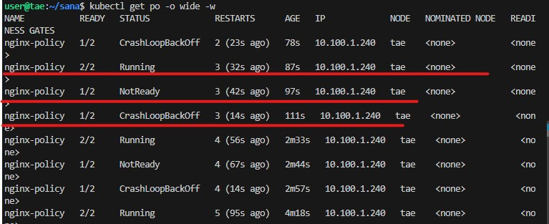

Now notice the above marked things in the picture it is showing that every 10 sec the container is getting created & stopped even if the exit code=0 the kubelet is trying create the container. This is the use of Restart Policy Always.

To know the exit code

# kubectl describe po nginx-policy

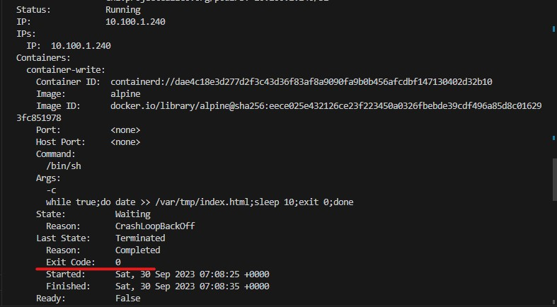

Now again chage the exit code to 1.

args: ["-c", "while true;do date >> /var/tmp/index.html;sleep 10;exit 1;done"]

Then create the pod again.

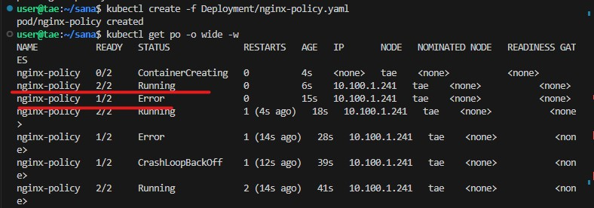

Now we can check thye exit code is 1. Even in that case also kubelet trying to create the pod.

# kubectl describe po nginx-policy

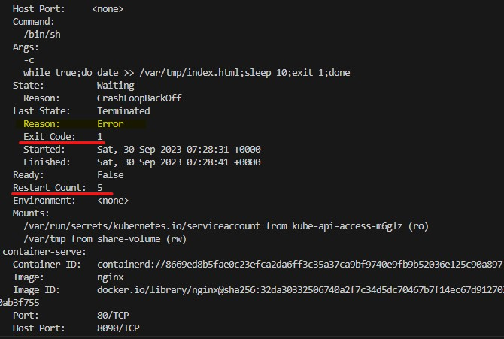

**OnFailure:**

Restart parameter will be written under the spec. like spec.restartPolicy

POD Lifecycle restart policy